**Shaik Imtiyaz Aaresh**

1001832769

**Answers:**

Question-1:

Number of test cases = 10

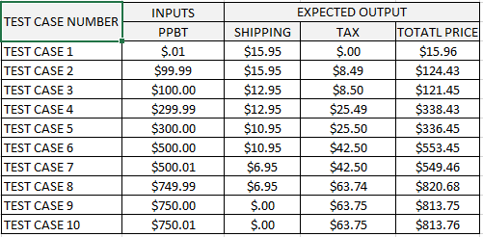

**Assumptions:**

1. There is no Product at $0.00 price or less than $0.00 price, the initial price is above $0.00
2. For any price above (Considered in TEST CASE 10), Shipping price is $0.00

Question-2:

Number of test cases = 10

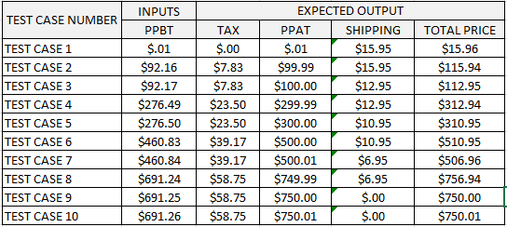

**Assumptions:**

1. There is no Product at $0.00 price or less than $0.00 price, the initial price is above $0.00
2. Here PPAT are the Product Price After Tax (PPBT+TAX) and shipping price is based on PPAT.

Question-3:

Number of test cases = 18

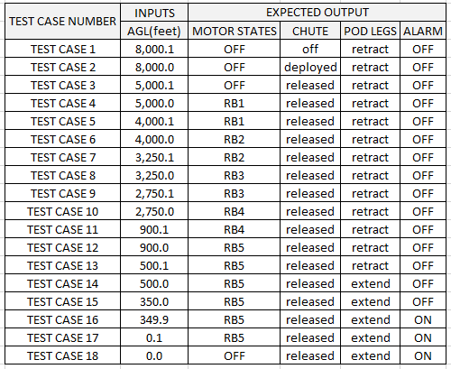

**Assumptions:**

1. Units of all the values in AGL column are in feet.
2. The alarm sounds below 350 feet AGL, at and above 350 feet Alarm is considered OFF.
3. From and above 8000.1 feet, the states of Motor state, chute, pod legs and alarm are same.
4. State transitions are considered instantaneous.

Question-4a:

1)

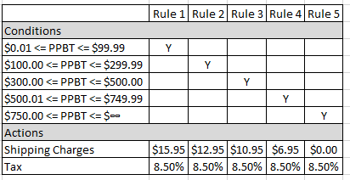

2) Number of test cases required 10

3) No, the number of test cases does not agree with the total 5 test cases from the above rules as it ignores the boundary values. 5 boundary values are untested.

Question-4b:

1)

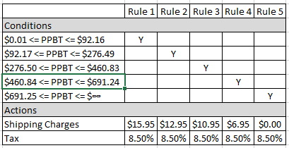

2) Number of tests required are 10

3) No, the number of test cases does not agree with the total 5 test cases from the above rules as it ignores the boundary values. 5 boundary values are untested.

Question-4c:

1)

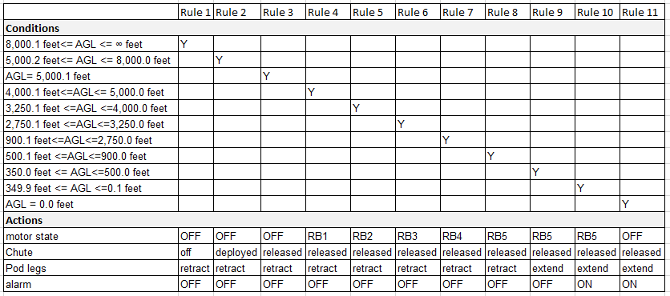

2) Number of test cases are 18.

3) No, here rules are 11 but we test cases 18 because in above table boundary cases are not considered. 7 boundary values are untested.

Question-5:

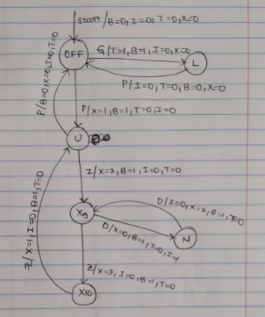

Here

U state is Normal state mode

Start is at OFF state